Basic operation

[Walking] Mouse

Click the left mouse game you want to move the target site, the role will automatically move to the location of the mouse click.

Hold down the left mouse button sustainable mobility.

[Keyboard] walking

Using the keyboard keys {W, A, S, D] can also be moved.

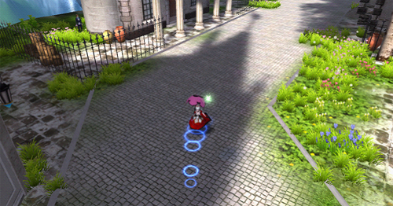

[Normal Attack]

Use the left mouse button / right click on a monster to attack.

[Attack] skills

Skills can be put onto the shortcut bar, then went through the shortcut keys [1 ~ 8, F1 ~ F4, Q, E, R, T] directly use it.

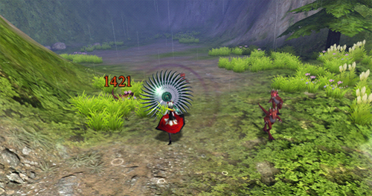

[Pick up items]

Left-click on the item or use the shortcut key "F" can pick up items.

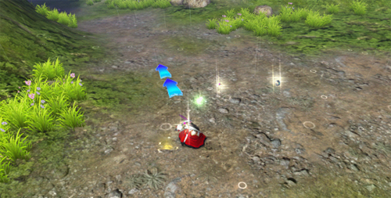

Use items

After opening the package, right click on the item you can use it. Can also drag and drop items from the package to the shortcut bar, press the corresponding shortcut keys to use it.

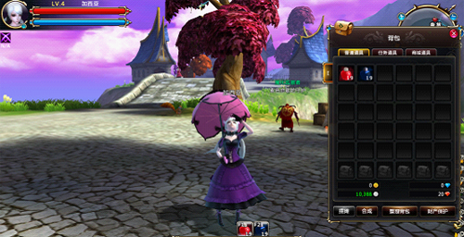

[Equipment] to wear

Move the mouse to click the right equipment items. Or select and drag items of equipment and equipment location corresponding role information panel. When the newly acquired equipment is higher than the current figure scoring equipment, you can press the "V" key to quickly dress up according to the system prompt.

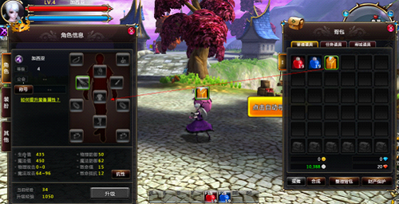

[Dialogue with the NPC]

Distance with the NPC within 10m, mouse over the icon NPC dialogue into the body, then left-click to interact with the NPC

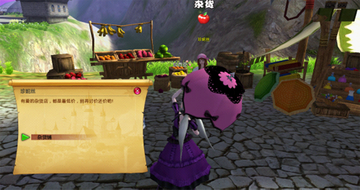

[Transaction]

In the non-combat status (via [TAB] key to switch the battle / non-combatant status) Right-click on the object and select [Application trading transactions].

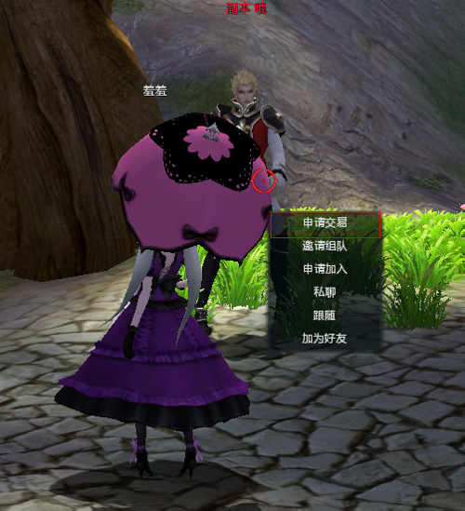

Only when both sides are locked transaction interface, it can be traded.

[Auto] wayfinding

Click on the map below [] button to automatically find its way to open the automatic routing panel. Double-click the NPC / player names can automatically find its way to the appropriate NPC / player, through this interface can also quickly find and apply for the team into the team.

